Appendix 1: Assignment submission cover sheet
ASSIGNMENT SUBMISSION COVER SHEET
Student Id: cse25-243

Student names: Yash Joshi
Student email: cse25-243@thuto.bac.ac.bw
Cohort:
Assignment title: joshi_yash_mar2026_cse105.docx
Date of submission: 20/03/2026
Programme of Study: Computer Systems Engineering
Year of Study: year 1
Intellectual property statement
By checking the box below, I certify that this assignment is my own work and is free from
plagiarism. I understand that the assignment may be checked for plagiarism by
electronic or other means and may be transferred and stored in a database for the
purposes of data-matching to help detect plagiarism. The assignment has not previously
been submitted for assessment in any other unit or to any other institution. I
have read and understood the Botswana Accountancy College plagiarism guidelines
policy.
☐ Agree Signature: Yash
Date: 20/03/2026

Website Planning & Documentation
Website Specifications
- Website Objective and Goals: The business objective of this website is to convert visitors into gym members by establishing a judgment free identity. According to industry research, gym intimidation prevents nearly 50% of individuals from joining a gym. Therefore the goal is to lower this barrier to entry by fitness plans, building trust through testimonials, and providing a contacting process.
- Target Audience: The core demographic consists of individuals in Gaborone and the surrounding areas nearby looking to get physically healthy, especially focusing on those who are currently overweight or underweight.
  - Demographics: Adults aged 18–45, university students and employers.
  - Technical Aptitude: Ranges from beginner to intermediate. The site uses a user interface to make sure that users with low digital literacy can navigate the site easily.
- Type of Website: This is a static website designed for marketing. It exists to inform people about the facility's offerings and capture their inquiries via an HTML5 feedback form.
2. Information Design & Taxonomy
Site Map & Page Details: The website consists of five pages with a structured and accessible content:
- Home (index.html): image slideshow, packages overview, text, and client testimonials.
- About Us (about.html): outline the gym's philosophy, and explains the judgment-free culture.
- Packages (packages.html): A detailed breakdown of the six training plans, pricing, and what each tier includes etc...
- Gallery (gallery.html): images of the equipment and training environment and people training.
- Contact (contact.html): outline the operating hours, contact details and an interactive form utilizing annotations for required fields.
Home

Contact
Gallery
Packages
About Us

3. Page Template Design
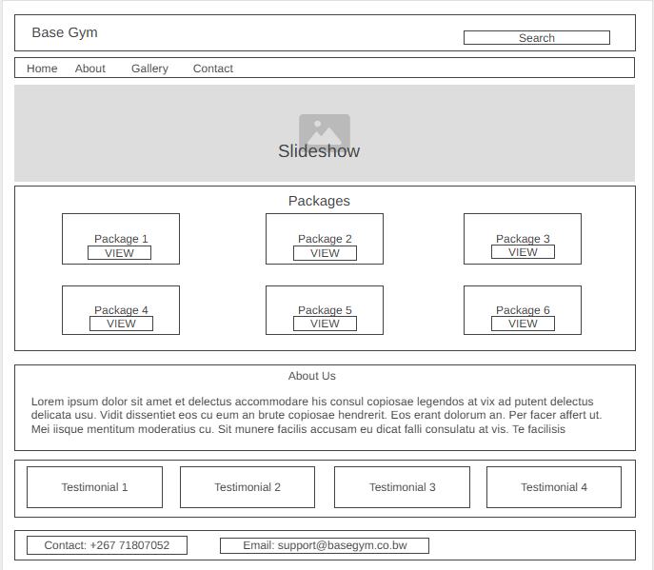
Active white space
4. Technical Brief
- Structural Layer (HTML): Used to create aaccessible page structure
- Presentation (CSS & Bootstrap): CSS is used for styling, while the Bootstrap 5 framework handles the responsive grid system. This ensures a mobile approach where content shrinks for smaller screens and expands for desktop monitors.
- Behavioral Layer (JavaScript): Utilized with the Bootstrap bundle to enable interactive elements, specifically the image carousel on the homepage.
- Development Environment: Visual Studio Code (VS Code)

